Trial Conditions

Trial 1:

* Sensory activation only – both left and right active between 400 and 600 time units
* Input from antJaw_02.txt
* Results in testOutput4.txt (then converted to .xlsx excel file)
* Result: jaws moved to close; need to alter input file to give opening behaviors negative values

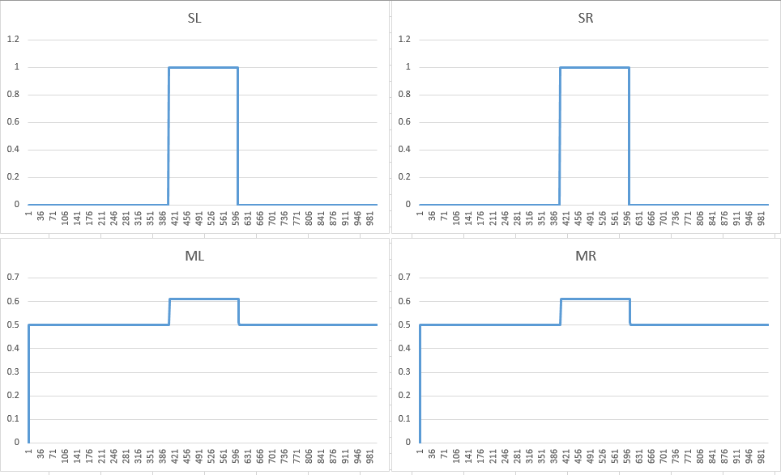

Trial 2:

* Same activation as Trial 1
* Switched values in input file (antJaw_03.txt) – sensor units were activating the closing behavior units, not opening behavior units. Did not make values negative, but altered the connections.
* Input from antJaw_03.txt
* Output: testOuput5.txt (then converted to .xlsx excel file)
* Result: jaws moved to open – desired behavior achieved

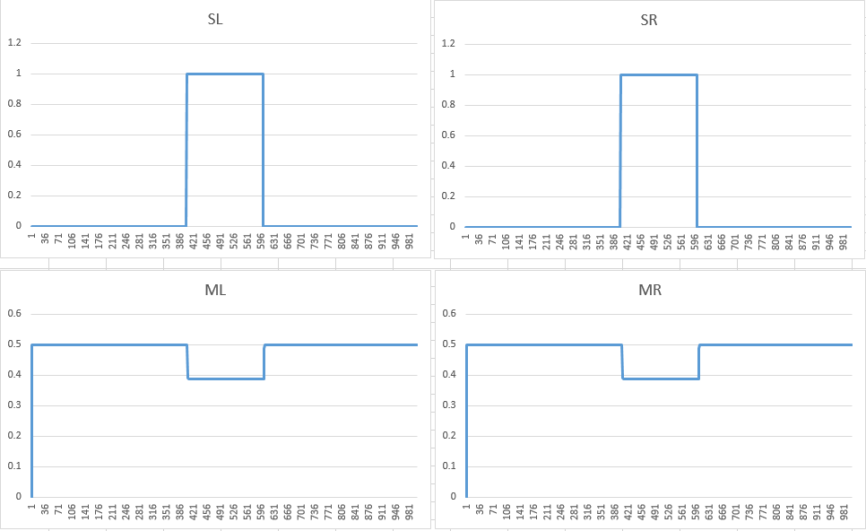

Trial 3:

* Activation: command alone between 300 and 700 time units
* Input: antJaw_03.txt (offset unit active, sensory units properly activate closing behavior units)
* Output: testOutput6.txt (then converted to .xlsx excel file)
* Results: mistakenly left sensory units active from last trial, jaws opened, then moved to open (past offset line – need to adjust weights so that extensor unit weights are lower than that of flexor unit weights)

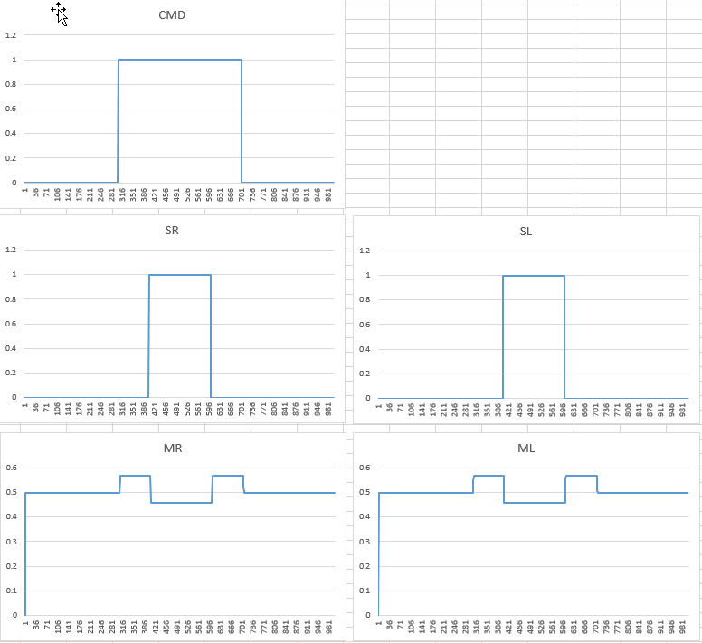

Trial 4:

* Activation: same as Trial 3 (without mistake) – command active between 300 and 700 time units (sensory units not mistakenly active this time)
* Input: antJaw_04.txt (extensor weights halved from that of previous input)
* Output: testOutput7.txt (then converted to .xlsx excel file)
* Results: motor units active at same time interval as command unit activation. Need to adjust weights, but desired behavior achieved

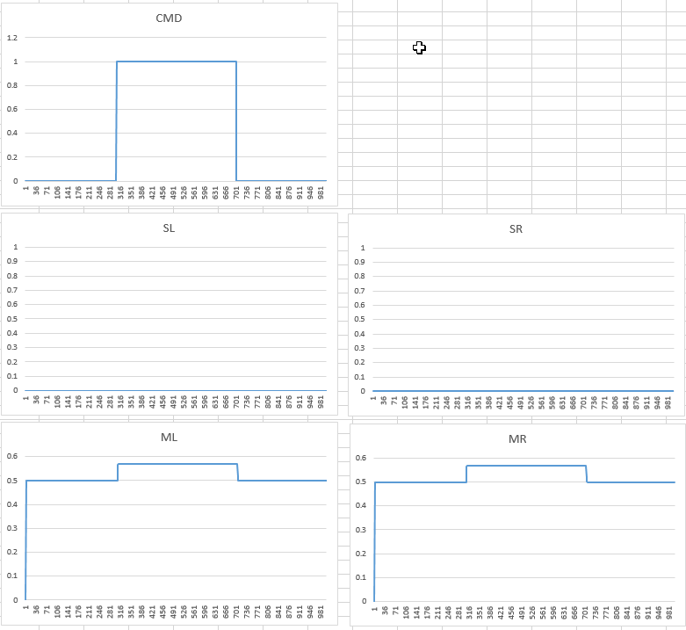

Trial 5:

* Activation: command active between 300 and 700 time units, sensor right active between 600 and 800 time units
* Input: antJaw_04.txt
* Output: testOutput8.txt (then converted to .xlsx excel file)
* Results: Right and left units may be mislabeled – when left sensory unit activated, the right motor unit activated (closer position). Labeling won’t change for next trial, but the weights will to keep things consistent

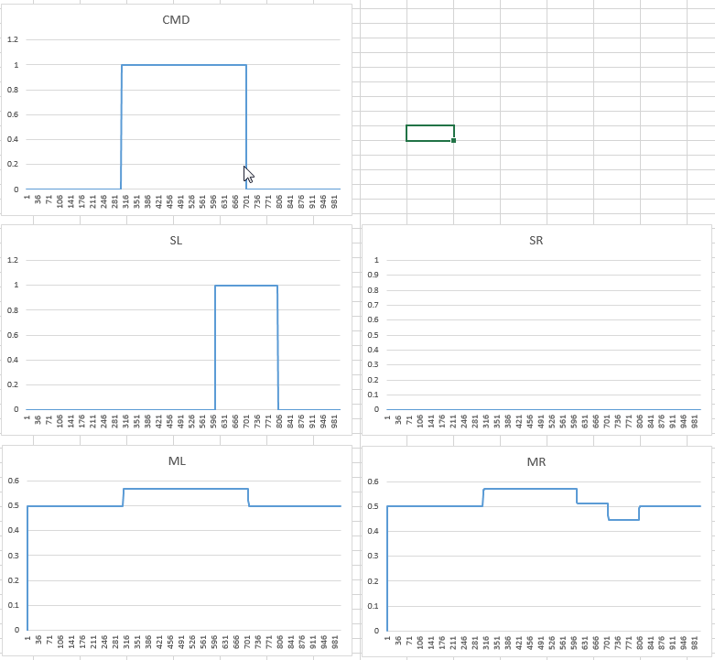

Trial 6:

* Activation: same as Trial 5
* Input: antJaw_05.txt (adjusted so that open behavior right connected to extensor right and vice versa – was reversed in previous network)
* Output: testOutput9.txt (then converted to .xlsx excel file)
* Results: Both motor units activated when command units activated. When left sensor unit activated, the left motor unit saw a decrease in activation but did not go under the offset level of 0.5. When command was inactive but sensor left was still active, the left motor opened beyond offset level (~0.45). Weights still need adjustment, but desired behavior was achieved.

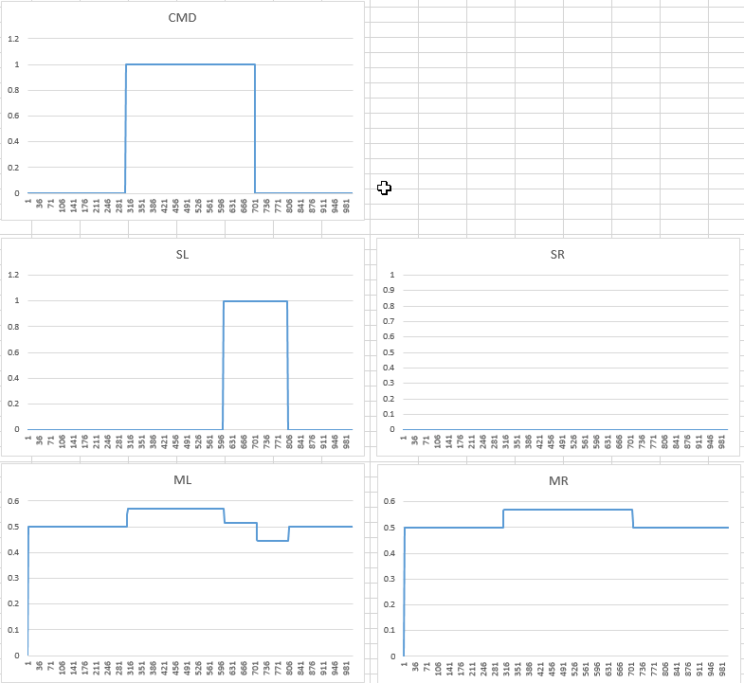

Trial 7:

* Activation: command unit active between 300-700 time units, sensor left unit active between 600-700 time units, and sensor right unit active
* Input: antJaw_05.txt (adjusted so that open behavior right connected to extensor right and vice versa – was reversed in previous network)
* Output: testOutput10.txt (then converted to .xlsx excel file)
* Results: Both motor units activated when command units activated. When left sensor unit activated, the left motor unit saw a decrease in activation but did not go under the offset level of 0.5. The same happened for the right motor unit but at a different time interval. When command was inactive but sensor left was still active, the left motor opened beyond offset level (~0.45). The same happened for the right motor unit but at a different time interval. Weights still need adjustment, but desired behavior was achieved.

Trial 7: